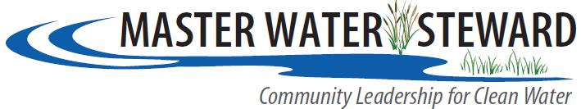
2014 APPLICATION
Contact Information
Name

I prefer all correspondence sent to: |  | Home |  | Business
Home Address
Business Address (If applicable)
Home Phone:
Cell Phone:
Work Phone:
E-Mail Address
I understand that I am responsible for raising funds for 1/2 of the cost of my Capstone Project.
I have attended an information session prior to submitting this application.

Tuition and Project Costs
Interest:
Why are you interested in becoming a Master Water Steward?

Current Community Involvement:
Please list any community organizations in which you participate, positions held and relevant accomplishments.

Please list your public speaking and meeting facilitation skills and experience.

Skills:
Please indicate your proficiency (L = Low, A = Adequate, P = Proficient) in the following:
 | E-mail |  | Microsoft Office (Word, Excel, PPT)
 | Internet/ Social Networking |  | ARC GIS or mapping program such as Google Earth

Please list other relevant computer or non-computer skills or interests:
Expectations:
What do you hope to gain from your participation in the Master Water Steward Program?

Vision:
What change are you hoping to affect in your community?
Do you have any conflicts with class dates as published?
Referred by (if applicable):
Letters of Recommendation attached (optional):
I understand and agree to the program requirements as stated on the Applicant Information Sheet. I also understand that as a Master Water Steward, I will serve as a resource to my community, and as such, my name, location and e-mail address will be made public.
Signature |  | Date

Please mail, e-mail, or fax your completed application form and any letters of recommendation to Peggy Knapp, 2150 3rd Ave. N. Anoka, MN 55303. Email PKnapp@freshwater.org or call 763-219-1252 with questions. Applications are due by January 13, 2014
Additional comments and notes:

